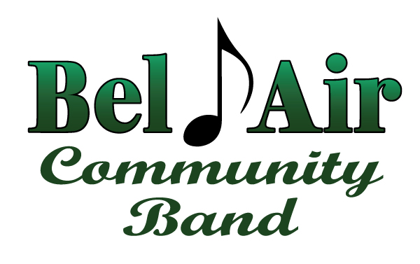

We would like to take this opportunity to welcome you to the William A. Humbert Amphitheater in Bel Air, MD. The Bel Air Community Band is honored to be your host for the Maryland Community Band Day. We hope all of you have fun and enjoy sharing your talents with fellow musicians as well as the community.

Your host,
Bel Air Community Band

Schedule of Performances for Band Day
1:00 – 1:45 Baltimore Symphonic Band
2:00 – 2:45 Olney Concert Band
3:00 – 3:45 Montgomery Village Community Band
4:00 – 4:45 Rockville Concert Band
5:00- -5:45 Williamsport Community Band
6:00 – 6:45 Columbia Concert Band
7:00 – 8:00 Bel Air Community Band

